1. 
2. 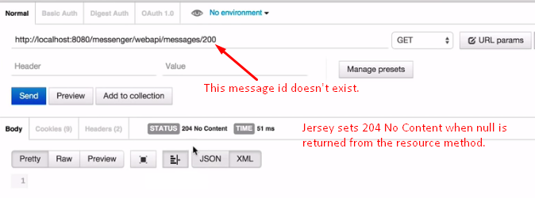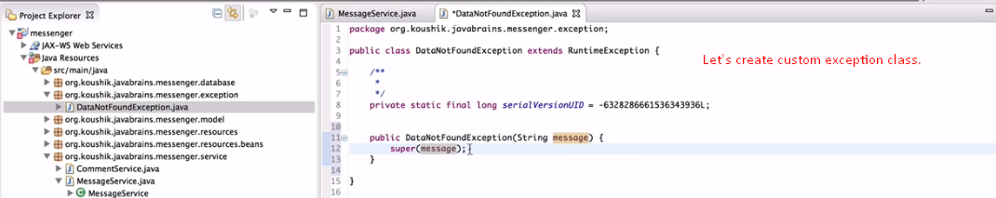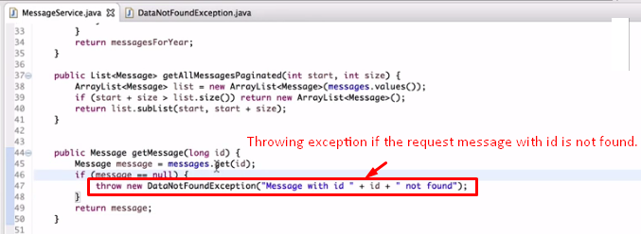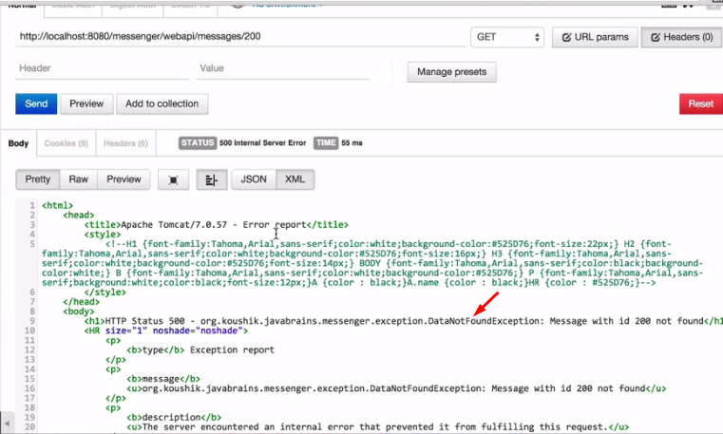  
   **NOTE**: Actually, the thrown exception bubbles all the way up to TOMCAT Container and tomcat contain has default behavior when it receives the exception. Its standard way to handle the exception is by showing the error page.
3. Now, we want to handle it.
4. Request goes to Tomcat and then to the jersey framework then to the resource handler method defined by us and where exception is thrown.
5. We want jersey framework to handle the exception thrown from the resource handler method.
6. **There is couple of steps**: We want to send the JSON response when an exception is thrown.
   1. Prepare the JSON response.
   2. Map it to the exception.
7. 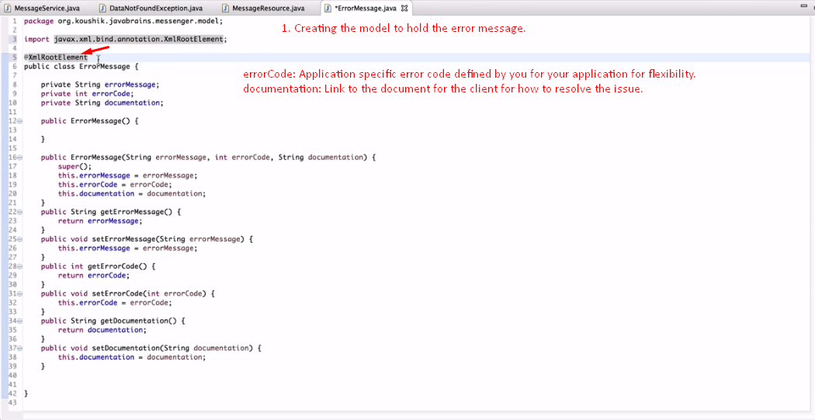
8. 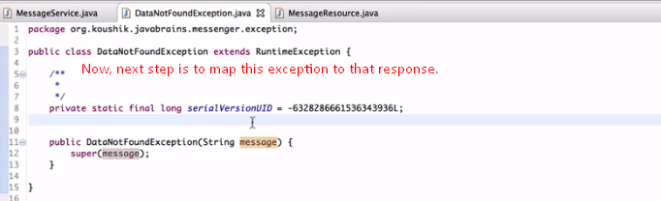
9. 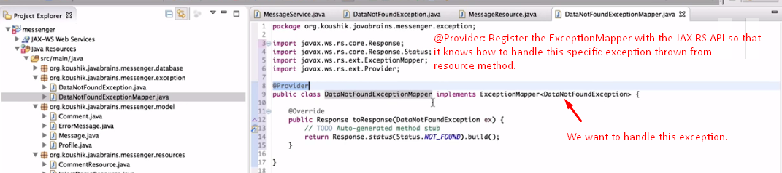
10. 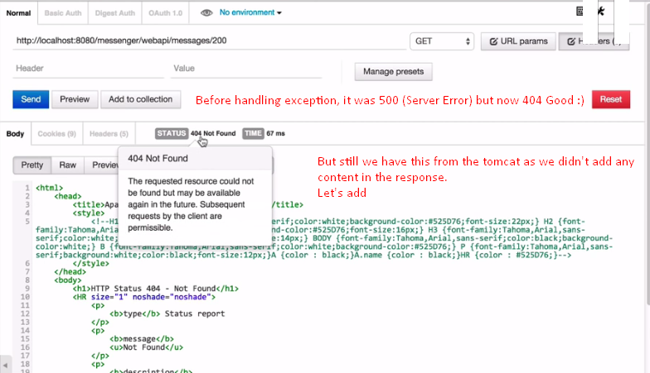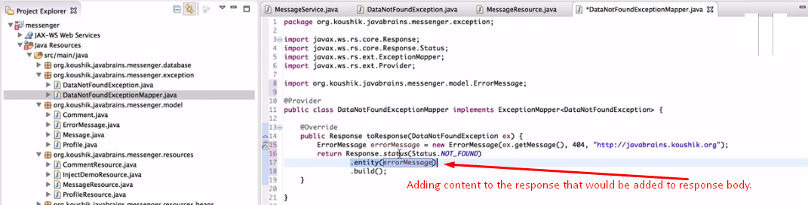
11. 